

**California Polytechnic State University Pomona**

DEPARTMENT OF ELECTRICAL & COMPUTER ENGINEERING

IINTRO TO MICROCONTROLLERS LAB

ECE 3301L.03

Report #1

**LAB 2 – Basic Input/Output using Microcontroller parallel ports**

Prepared by

**Kelly Williams**

**and**

**Isaac Bernal**

Presented to

Felix Pinai

September 12, 2024

# TABLE OF CONTENTS

TABLE OF CONTENTS 2

INTRODUCTION 3

Objective 3

Summary 3

DATA AND RESULTS 4

CONCLUSION 4

# INTRODUCTION

## Objective

To gain a more focused understanding of microcontrollers and how to use them paired with other devices and hardware. Students will learn how to connect more external devices and sensors to the Pickit and adjoining development board, and practice writing the accompanying code for different applications of similar hardware configurations.

## Summary

This lab is built on concepts from Lab 1, with the addition of LEDs, DIP switches, and most importantly, writing sections of the code ourselves. For software, students learned how to interpret datasheets into real world applications, using descriptions of ports, registers, and memory addresses to implement into the required coding application. Software students also learned how to further communicate with and command the Pickit microcontroller, debugging the code ourselves and learning to spot problems even if the code had no error. For hardware, students learned how to connect more external devices to the Pickit development board. Hardware students were able to troubleshoot the circuit and find issues with wiring and hardware configuration.

# DATA AND RESULTS

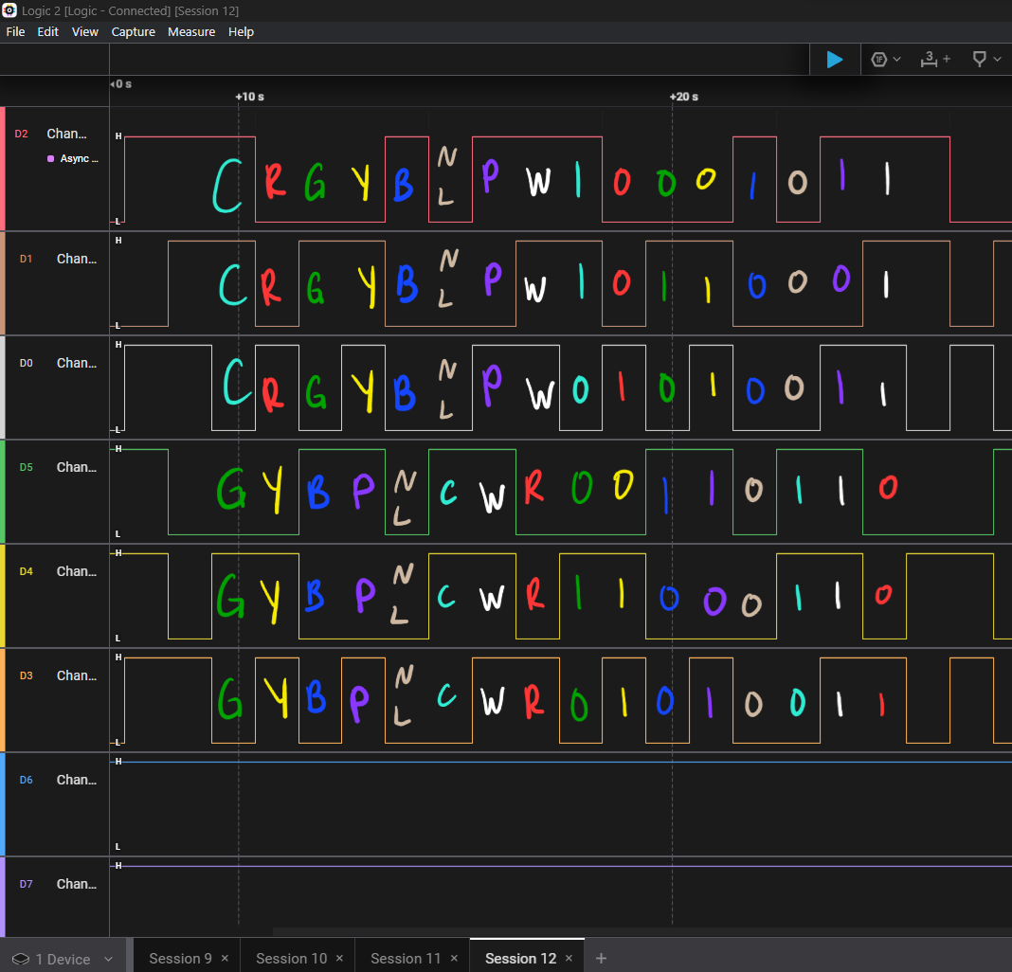

Output Signals from the final part of the lab, where students identified RBG colors from signals.

# CONCLUSION

This lab successfully expanded our understanding of microcontroller applications and their integration with various external devices. Building on the foundational concepts from Lab 1, we gained practical experience in connecting LEDs, DIP switches, and other components to the Pickit development board. Through hands-on exercises, we honed our skills in translating datasheet information into functional code, and improved our debugging abilities by addressing both software and hardware issues. This comprehensive approach not only reinforced our theoretical knowledge but also enhanced our problem-solving skills, preparing us for more complex microcontroller projects in the future.